WireFu

Game Documentation

By

Hwan Jung

Jason Ko

Ulysses Villagomez

1. WireFu
   1. Copyright Information
2. Table of Contents
3. Section I: Project Overview
   1. Team Personnel (with contact info)
      1. Production Team
         1. Producer
         2. Assistant Producer
         3. etc
      2. Design Team
         1. Design Lead
         2. Level Designer #1
         3. Writer #1
         4. Etc
      3. Programming Team
         1. Tech Lead
         2. Additional Programmers
      4. Art Team
         1. Art Lead
         2. Additional Artists
      5. QA Team
         1. QA Lead
         2. Additional Testers
      6. External Contractors
         1. Mocap Company
         2. Composer
         3. Sound Effects House
         4. CGI house
         5. Voice Director
         6. Etc
   2. Executive Summary
      1. High Concept
      2. The Hook
      3. Story Synopsis and Setting
      4. Genre and Scope (number of missions)
      5. Visual Style (2D, 3D Isometric, etc)
      6. Engine (and editor?)
   3. Core Gamplay (What does the player do?)
      1. Single-player
      2. Co-op?
      3. Multiplayer
   4. Game Feature
      1. Gameplay innovations
      2. Advances in AI
      3. Artistic techniques and achievements
      4. License tie-ins
      5. Other features that will make this game better than others like it on the market
   5. Project Scope
      1. Number of distinct locations
      2. Number of levels/missions
      3. Number of NPCs
      4. Number of weapons
      5. Number of vehicles
      6. Etc
   6. Target Audience
   7. Delivery Platforms
4. Section II: Story, Setting, and Character
   1. Story
      1. Back story
      2. In-game story (What happens during the game)
   2. Environments
      1. Area #1
         1. General description
         2. Physical characteristics
         3. List of levels that take place in this area
      2. Area #2
      3. Etc
   3. Characters
      1. Player Character(s)
         1. Personality
         2. Back story
         3. “Look”
         4. Special abilities
            1. Ability #1

When it’s acquired

How the player invokes it

Effect it has on the world

Graphic effect that accompanies it

* + - * 1. Ability #2
        2. Etc.
      1. Weapon set
      2. Regular animation
         1. Walk, run, climb, roll, swim, crouch, crawl, idle, etc
      3. Situation-specific animations
      4. Statistics (if applicable)
    1. Allies
       1. Ally #1
          1. Personality
          2. Relationship to player character
          3. Back story
          4. “Look”
          5. Special abilities
          6. Weapon set
          7. Regular animations
          8. Situation-specific animations
          9. Statistics
       2. Ally #2
       3. Etc
    2. Bad Guys
       1. Ultimate bad guy
          1. Personality
          2. Relationship to player character
          3. Back story
          4. “Look”
          5. Special abilities
          6. Weapon set
          7. Regular animations
          8. Situation-specific animations
          9. Statistics
       2. Sub bosses
       3. Grunts
    3. Neutrals (World NPCs)
       1. NPC #1
          1. Attitude towards player character
          2. Function in the game
          3. Animation set
       2. NPC#2
       3. Etc

1. Section III: Combat
   1. Weapons
      1. Weapon #1
         1. General description and most effective use
         2. When it is first acquired
         3. Art
         4. Statistics (for both primary and secondary fire)
            1. Type of ammunition
            2. Shots per clip
            3. Fire rate
            4. Reload rate
            5. Damage inflicted
            6. Range
      2. Weapon #2
      3. Etc
   2. Spells
      1. Spell #1
         1. Description
         2. When it is first acquired
         3. How the player invokes it
         4. Statistics
            1. Range
            2. “Refire rate”
            3. Damage
            4. Area of effect
      2. Spell #2
      3. Etc
   3. Inventory Items/Gadgets
      1. Item #1
         1. Brief physical description of the object
         2. When it is first acquired
         3. What it does
         4. Art
         5. How the player equips it
         6. Statistics
      2. Item #2
      3. Etc.
   4. Powerups
      1. Powerup #1
         1. Brief physical description of how the object is represented in the world
         2. When it is first acquired
         3. Art
         4. What it does
         5. Statistics
            1. Effects
            2. Duration
      2. Powerup #2
      3. Etc.
   5. Melee (hand-to-hand) combat
      1. Attacks
      2. Defensive moves
      3. Combos
   6. Vehicles
      1. Capacity
      2. Speed
      3. Armor
      4. Weaponry
      5. Combat statistics
      6. Etc.
2. Section IV: Controls
   1. PC Keyboard/Mouse Commands
      1. Default keys for movement controls
         1. Move forward
         2. Move backward
         3. Strafe left
         4. Strafe right
         5. Jump
         6. Etc.
      2. Default keys for using weapons
         1. Primary fire
         2. Alt-fire
         3. Reload
         4. Previous weapon
         5. Next weapon
         6. Etc.
      3. Inventory access and manipulation
      4. Menu access
   2. Console Platform #1
      1. A picture of the controller explaining what each button does
      2. Movement controls
      3. Weapon controls
      4. Action controls
      5. Combos
      6. Force-feedback options
   3. Console Platform #2
   4. Etc.

# Interface

## Camera

This will purely be a 2D platformer game. The camera will always follow the character as he moves throughout the levels.

## HUD

* + 1. Worldview
    2. Status information
       1. Health
       2. Energy
       3. Armor
       4. Weapon equipped
       5. Ammo remaining
       6. Mission objectives?
    3. Crosshairs (targeting reticule)
    4. Radar or proximity map?

## Menus

### Game screen flow diagrams

## Main Menu

### New Game

Begin game on level 1.

### Options

* Music: Left-click to enable or disable the music. Press ‘1’ to increase the volume or ‘2’ to decrease the volume
* Sound: Left-click to enable or disable sound effects (e.g. – pickup powerup)

### Credits

This will display the developers of the game and any artworks, sounds, and music borrowed from other sources.

### Exit

Quits the game.

# Artificial Intelligence

None needed for this game.

# Detailed Level/Mission Descriptions

## Level 1

### Synopsis

Level one is an introductory level allowing the player to familiarize himself with the controls of the character. A ramp and zipline is also introduced here.

### Mission objectives (player goals)

The ojective of the level is to reach the finish platform (yellow) as quickly as possible.

### Physical description

Apartment suburban area

### Map (concept)

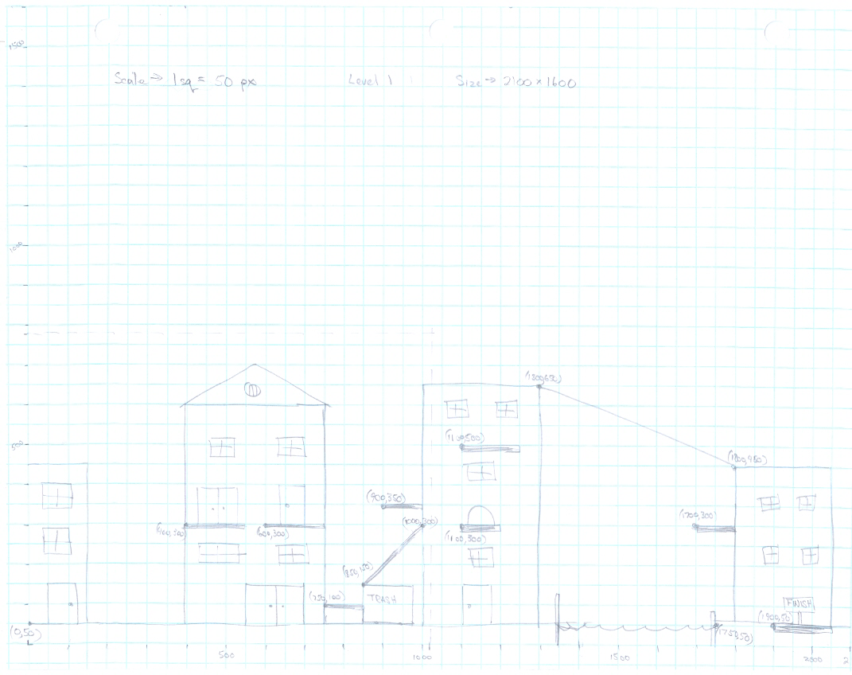

### Powerups

None.

## Level 2

### Synopsis

The player is introduced to the Jump powerup in this level, and more jumping skills will be required to complete the level.

### Mission objectives (player goals)

The ojective of the level is to reach the finish platform (yellow) as quickly as possible.

### Physical description

Apartment suburban area

### Map (concept)

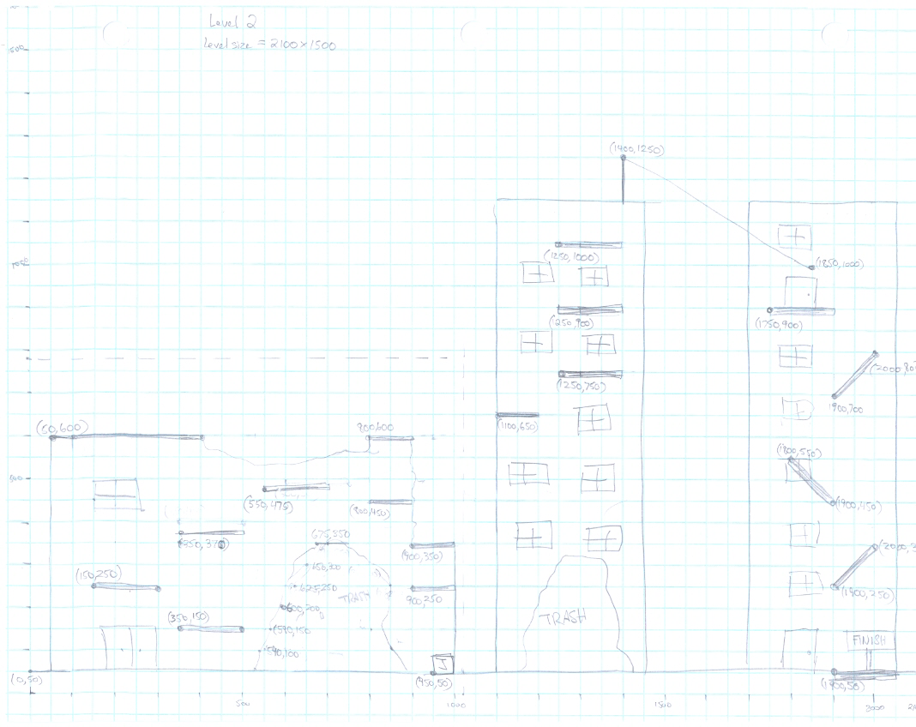

### Powerups

One Jump powerup.

## Level 3

### Synopsis

The player is introduced to the Jump powerup in this level, and more jumping skills will be required to complete the level.

### Mission objectives (player goals)

The ojective of the level is to reach the finish platform (yellow) as quickly as possible.

### Physical description

Climbing skyscrapers.

### Map (concept)

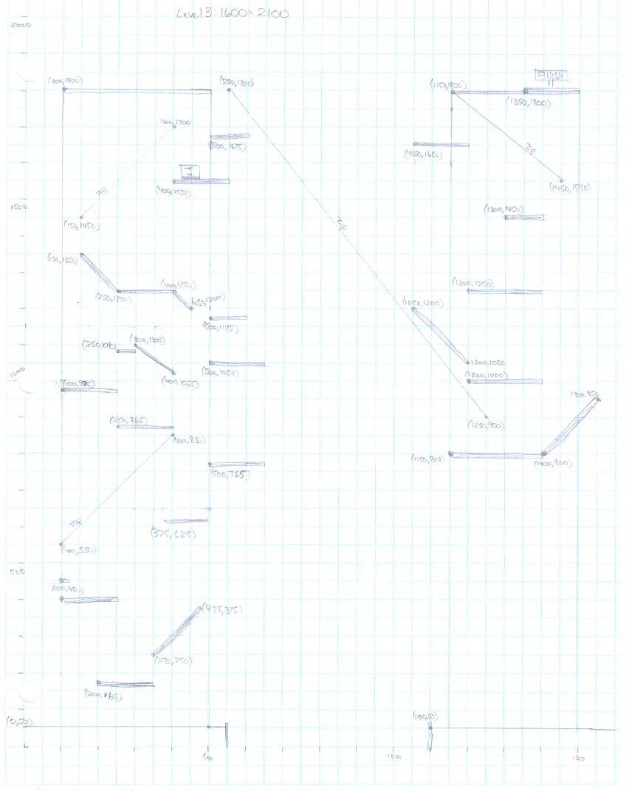

### Powerups

One Jump powerup.

## Level 4

### Synopsis

This level takes place up high on the buildings, meaning there is no ground platform. The player may fall to his death if he does not carefully make his jumps.

### Mission objectives (player goals)

The ojective of the level is to reach the finish platform (yellow) as quickly as possible.

### Physical description

Up high on the buildings.

### Map (concept)

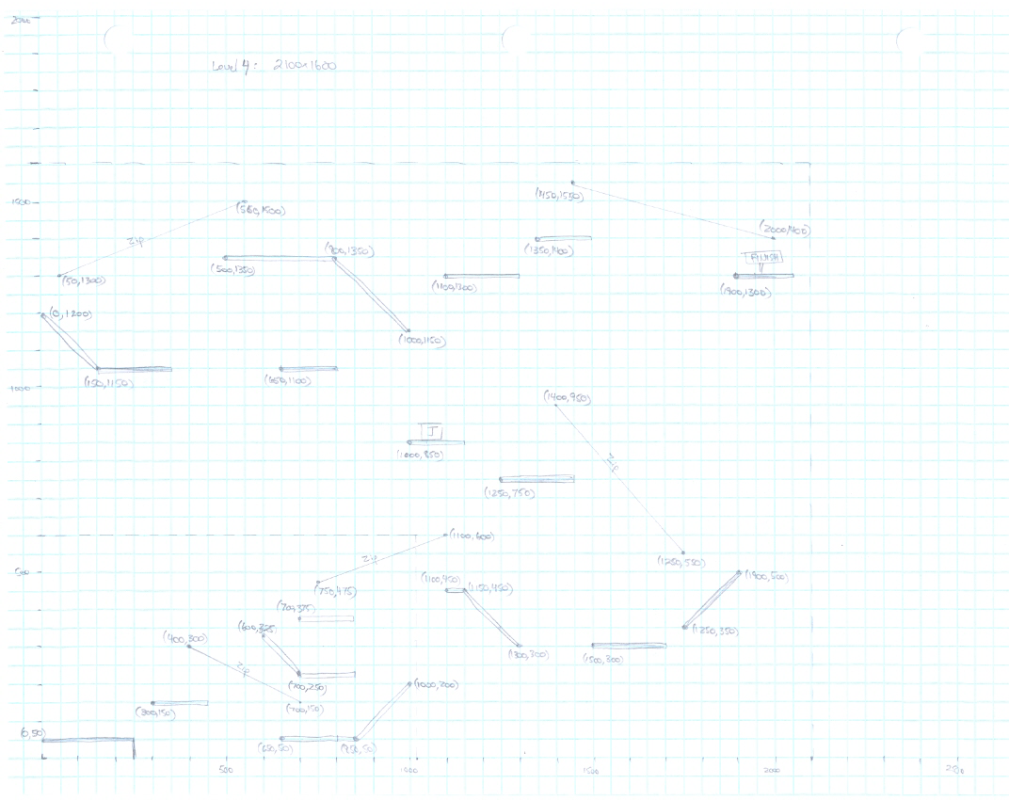

### Powerups

One Jump powerup.

## Game Modes

This is a single-player game.

### Rules

The player will begin the level in the idle position. The clock begins to run as soon as the player moves the character. The faster the player can reach the victory condition the higher he will score.

### Death and restarts

The character will die if he falls from too high of an altitude or if he falls off the level. When this occurs, the character will restart the level from the beginning and the clock will also be reset to zero. If the player becomes stuck or he just wishes to restart the level, he may do so by pressing ‘r’.

### Victory condition

The character must touch the yellow platform at the end of the level to stop the clock. At this point, he will receive a score.

1. Section XI: Asset List
   1. Art
      1. Model & Texture List
         1. Characters
            1. Player character

Undamaged

Damaged

* + - * 1. Allies
        2. Bad guys
        3. Neutrals
      1. Weapons
         1. Weapon #1
         2. Etc
      2. Equipment/Gadgets
         1. Item #1
         2. Etc
      3. Environmental Objects
         1. Object #1
         2. Etc
    1. Animation list
       1. Characters
          1. Character #1

Move #1

Move #2

Etc.

* + - * 1. Character #2
        2. Etc.
      1. Weapons
         1. Weapon #1

Firing animation

Reload animation

Projectile in flight animation

* + - 1. Destructible or animated objects in the world
         1. Object #1
         2. Object #2
         3. Etc.
    1. Effects list
       1. Weapon effects list
          1. Firing effects
          2. Hit effects
          3. Etc.
       2. Environmental effects
          1. Decals
          2. Smoke
          3. Sparks
          4. Fire
          5. Explosions
          6. Etc.
    2. Interface Art List
       1. Icons
       2. Buttons
       3. Menus
       4. Windows
       5. Etc.
  1. Sound
     1. Environmental Sounds
        1. Walking/running sounds on different surfaces
        2. Foley sounds of character actions within game
        3. Explosions
        4. Doors opening and closing
        5. Etc.
     2. Weapon Sounds
        1. Weapon #1
           1. Firing sounds
           2. Hit sound
           3. Reload sound
        2. Weapon #2
        3. Etc.
     3. Interface Sounds
        1. Various clicks, beeps, etc., as the player maneuvers through the menus
        2. Alert/acknowledgement sounds as the player picks up objects or his game state changes
  2. Music
     1. Ambient
        1. Loop #1 + duration
        2. Loop #2
        3. Etc.
     2. Action
        1. Loop #1 + duration
        2. Loop #2
        3. Etc.
     3. Victory loops
     4. Defeat Loops
     5. Cutscene music
        1. Piece #1
           1. General description of mood and accompanying action
           2. Duration
        2. Piece #2
        3. Etc.
  3. Voice
     1. Actor #1 lines
        1. Line #1. Each line in the game must have a unique identifying file name. Don’t forget to include various screams, yells, grunts, laughs, and other utterances
        2. Line #2
        3. Etc.
     2. Actor #2 lines
     3. Etc.

1. Section XII: Localization Plan
   1. Languages with full text and voice localization
   2. Languages with text localization only
   3. Text to be localized
      1. In-game text
      2. Game interface text
   4. Voice to be localized
2. Section XIII: Major Event Planning
   1. Trade Shows
   2. Special Publicity Events
   3. PR/Marking Support
   4. Sales Team Support
   5. Prerelease Demo
3. Section XIV: Technical Summary
   1. Single-Player
      1. PC
         1. Minimum system requirements
         2. Recommended system requirements
         3. Number of characters viewable at once
         4. Max # polys per character
         5. Max # polys per level
      2. Console Platform #1
      3. Etc.
   2. Multiplayer
      1. Type of connectivity (Splitscreen? LAN? Online?)
      2. Max # simultaneous players
      3. Client-server? Peer-to-peer?
      4. Etc
4. Section XV: Miscellaneous
   1. Acronyms used in this document
   2. Definition of terms
5. Section XVI: References
   1. Games
   2. Movies
   3. Books
   4. Art